**Install SQL Server 2008 Express (including Management studio)**

Microsoft SQL Server 2008 Express with Tools is a free, easy-to-use version of the SQL Server Express data platform that includes the graphical management tool: SQL Server Management Studio (SMSS) Express. SQL Server 2008 Express provides rich features, data protection, and fast performance. It is ideal for small server applications and local data stores.

**Steps:**

1. On the left column, click on "Installation" Then click on the first link : "new SQL Server stand-alone installation"

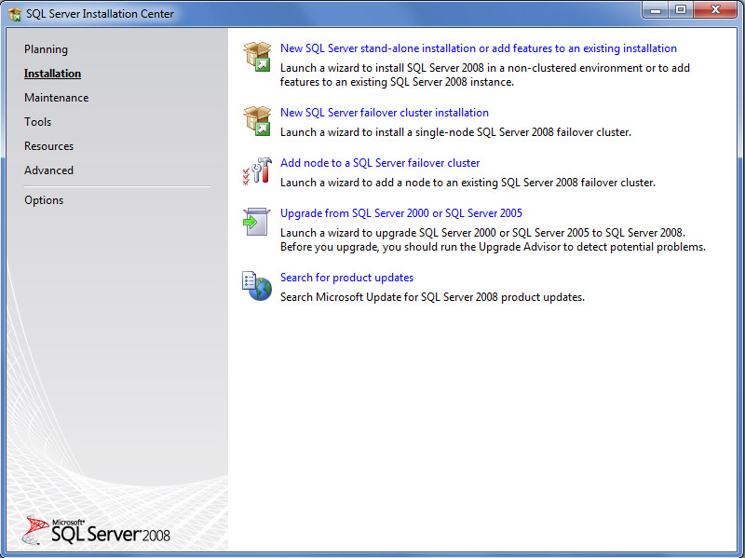

2. Setup support rules reopen. Once all operations completed, click OK

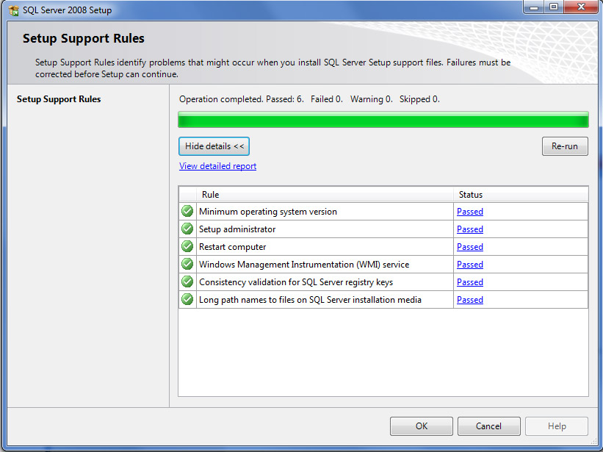

3. The "setup support files" tab opens. Click on "install"

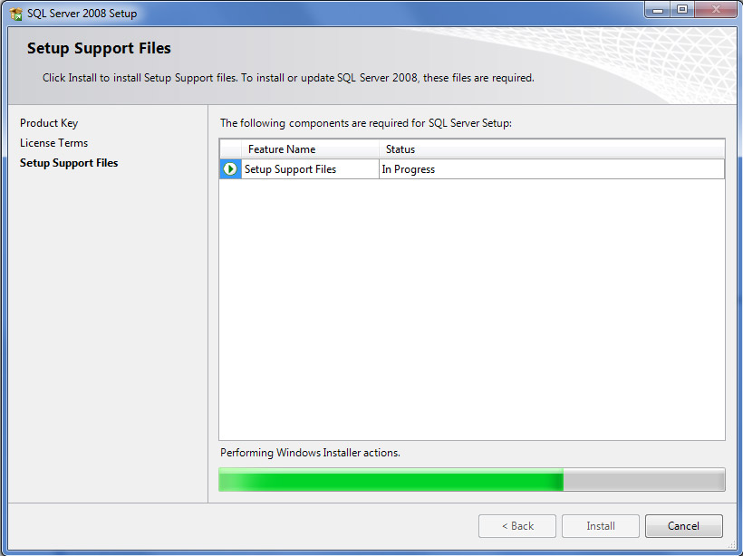

4. Once installed, the Setup Support Rules reopen. Check that all operation passsed, then click "next"

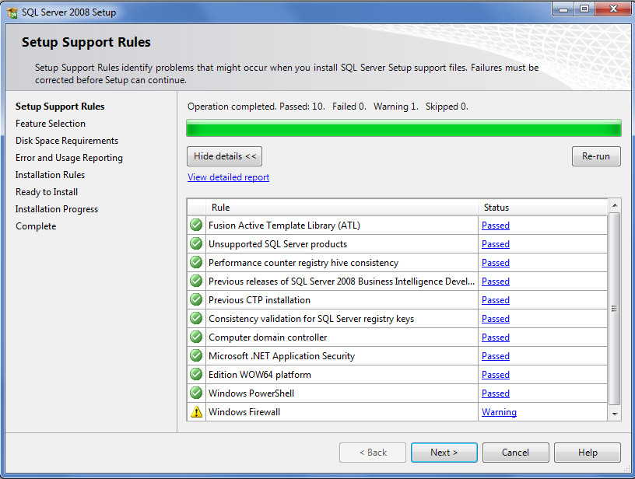

5. The SQL Server 2008 Setup opens with a first "product key" tab As we use a specific free version of SQL Server, no activation key is needed. Simply click "next"

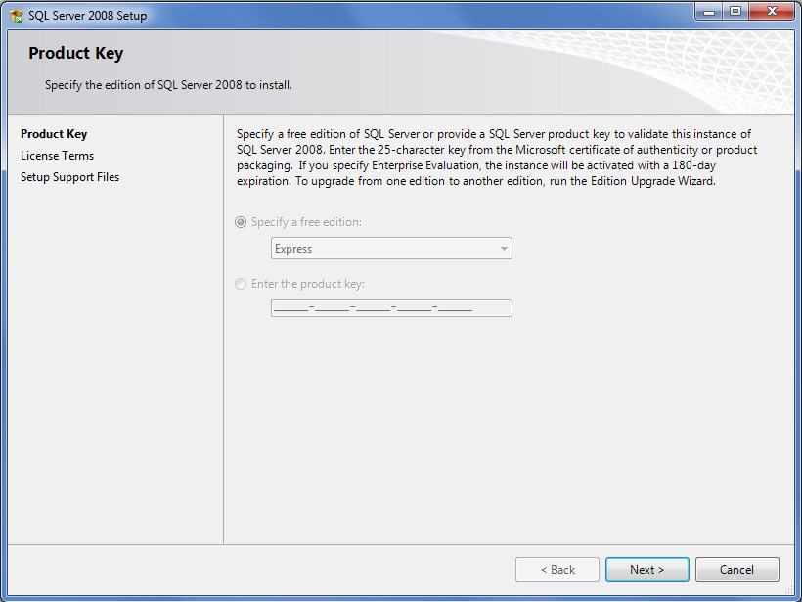

6. Check the box "I accept the licence terms" Click on "Next"

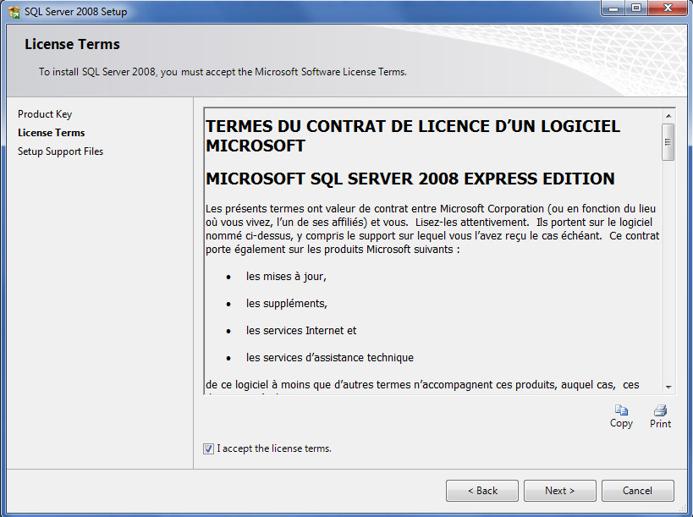

7. On the "features selection" tab choose "Data Engine Services" and "Management tools" (this is the Management Studio Express)check the features directory (no need to change normally) click "next"

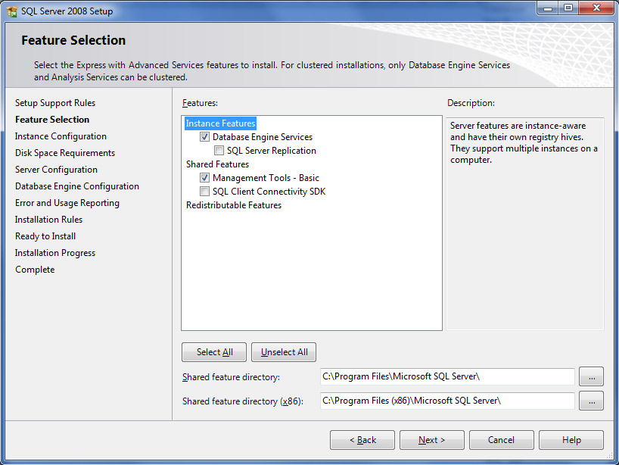

8. On the "instance Configuration" check that the parameters are like the screenshot on the left (nothing to change normally) Click "Next"

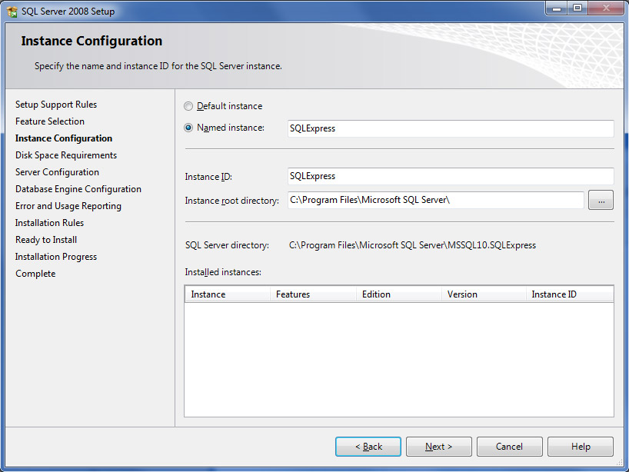

9. Disk space requirements tap -> Click Next

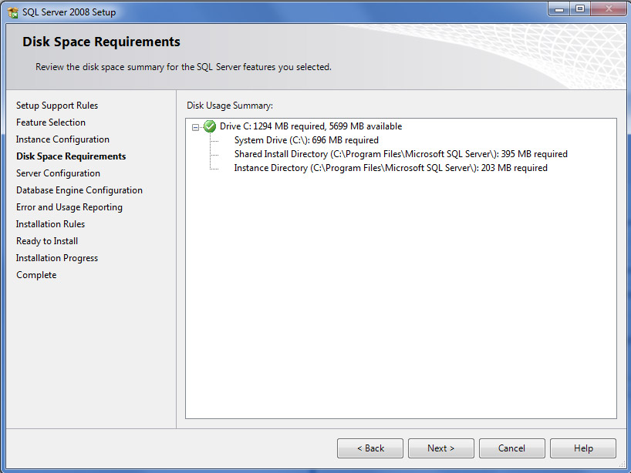

10. **Server Configuration:**

For the first service "SQL Server Database Engine", on the account name, choose the first result of the listbox (in our case NT AUTHORITY\NETWORK)  
Then click "Next".

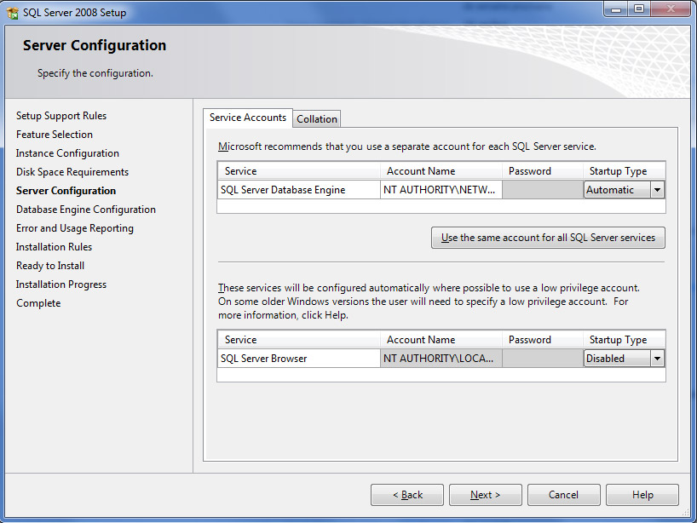

11. **Database Engine Configuration:**  
- Chose "Mixed mode"  
- Enter the  password **: p@ssword13 (Remember this – whatever you choose)**  
- Specify SQL Server administrator : Click on "add current user"  
- Click "Next"

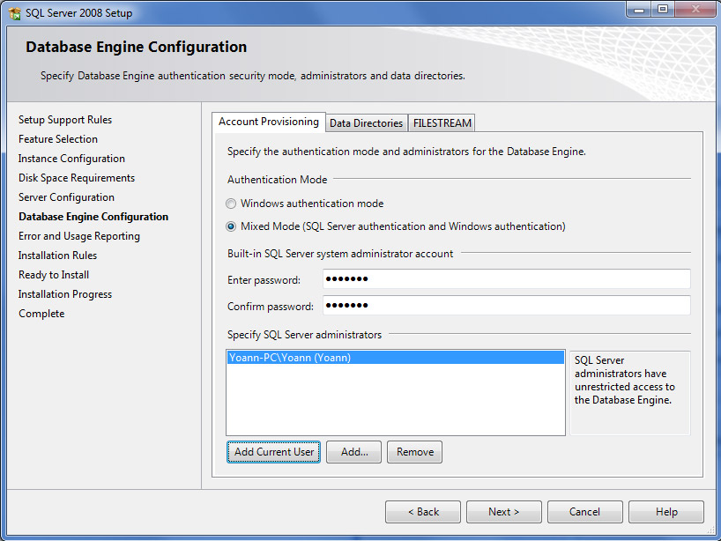

12. Error and Usage Reporting

Click next

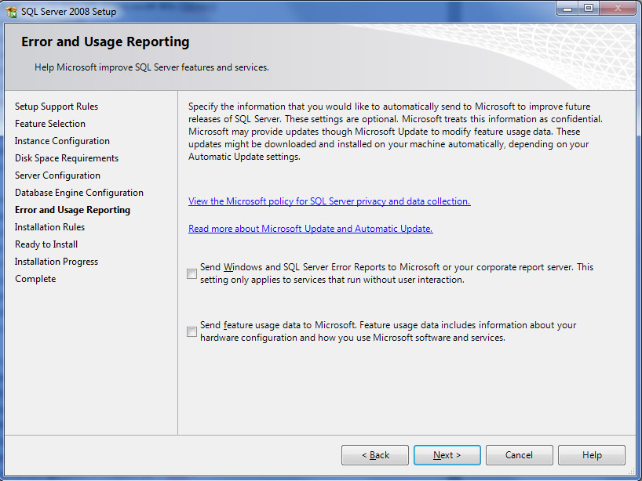

13. Installation Rules :  
Once Operation completed, click "Next"

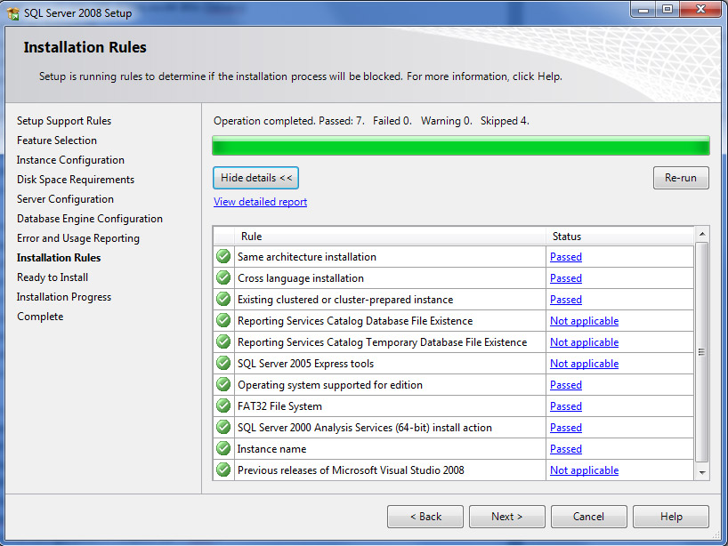

14. Ready to install:  
Click "Install"

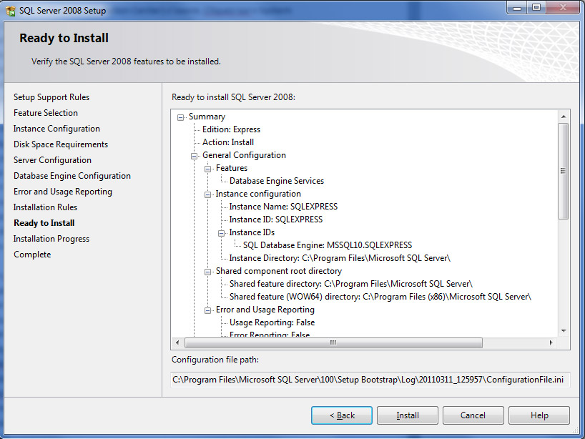

15. Installation Progress  
- Wait until Installation is finished  
- Ensure "Database Engine Services" and "Management Tools Basic" are successfully installed  
- Click "Next"

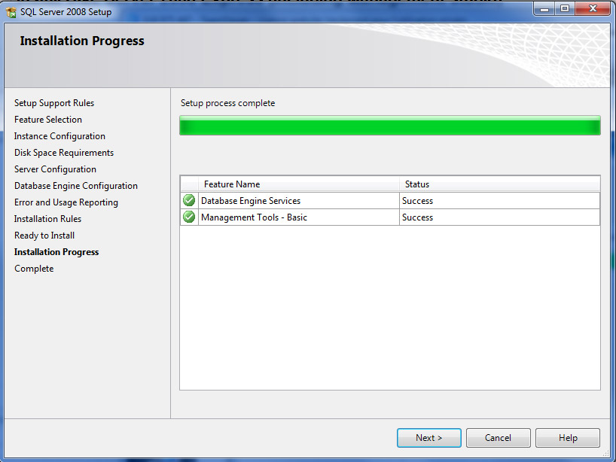

16. Complete:  
Once installed, click on "Close"

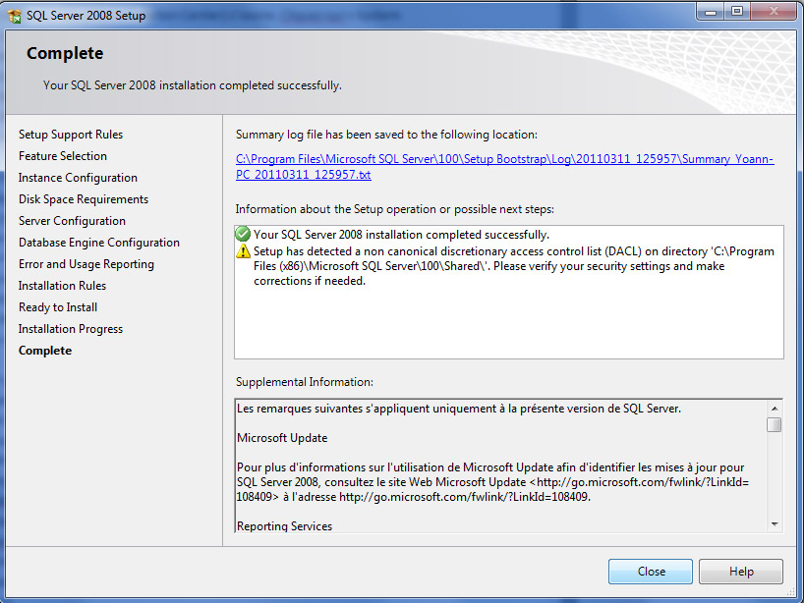

17. To ensure SQL Express is running correctly, run "SQL Server Configuration Manager"  
On the left column click on "SQL Server Services  
On the right column, ensure that SQL Server (SQLEXPRESS) is running correctly (otherwise right-click on the device to start it)

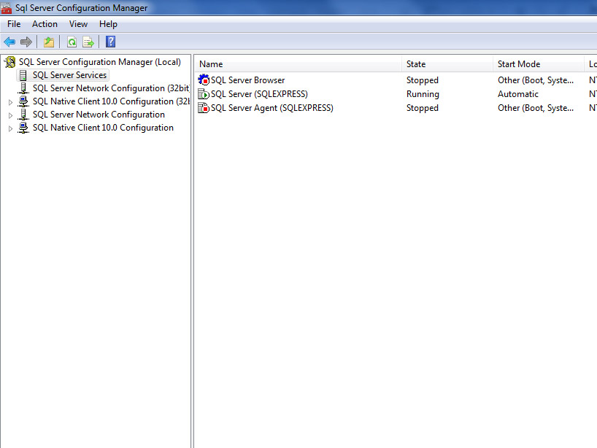

18. The SQL Server Connection Windows appears.  
Choose the following parameters:  
- Server Type: Database Engine  
- Server Name: (Name of your computer)\SQLEXPRESS*  
- Authentication: SQL Server Authentication (if you can only see windows authentication, you probably missed to choose  
"Mixed Mode" at the Database Engine Configuration step   
- Login: sa (by default)  
- Password: the password you defined at the Database Engine Configuration step (octopus in our case)

* You can find the name of your computer on the control panel>System

